Adjustment Layers Packet

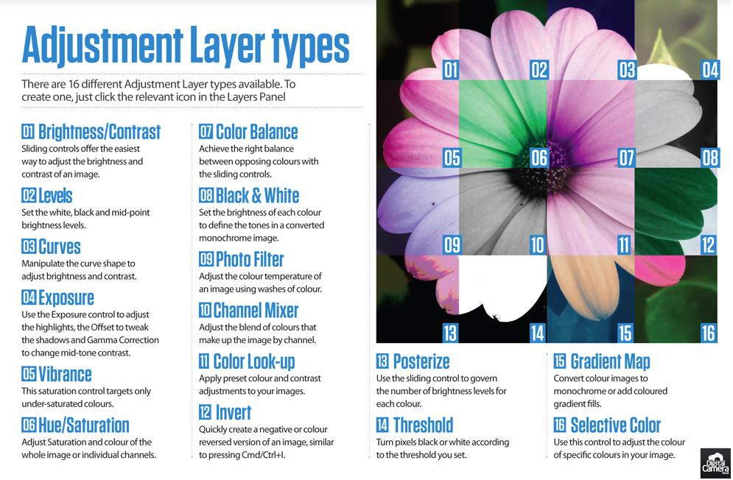

Assignment:
- Practice each tutorial individually. Be sure you understand the technique before moving onto the next.
- DO NOT SAVE each tutorial. Just practice and close.
- When you finish all the practice tutorials - complete the final project.
* Last page of packet

To find your practice images:
student resource > art department > martin > basic photo > adjustments > chapter 3

