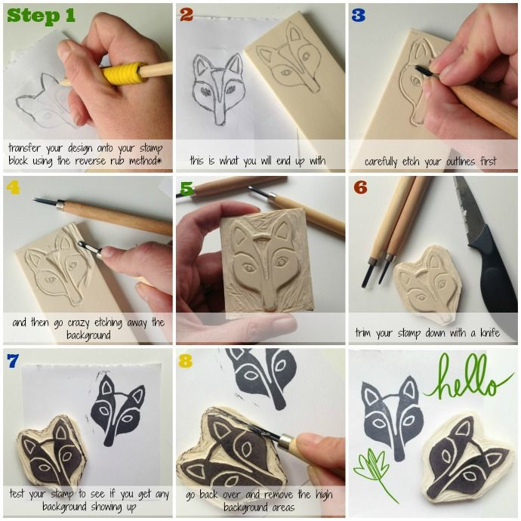
Signature Stamp
the “How to” of carving your first Linoleum Block

